***Name:***

***Dawood Sarfraz***

***Roll no:***

***20p-0153***

***Section:***

***BSCS-9A***

***Assignment no 4:***

***Build Automation (Pre-Processors)***

***Submitted to:***

***Dr. Omar Usman Khan***

***Task 3: Converting to Library***

***Static Library:***

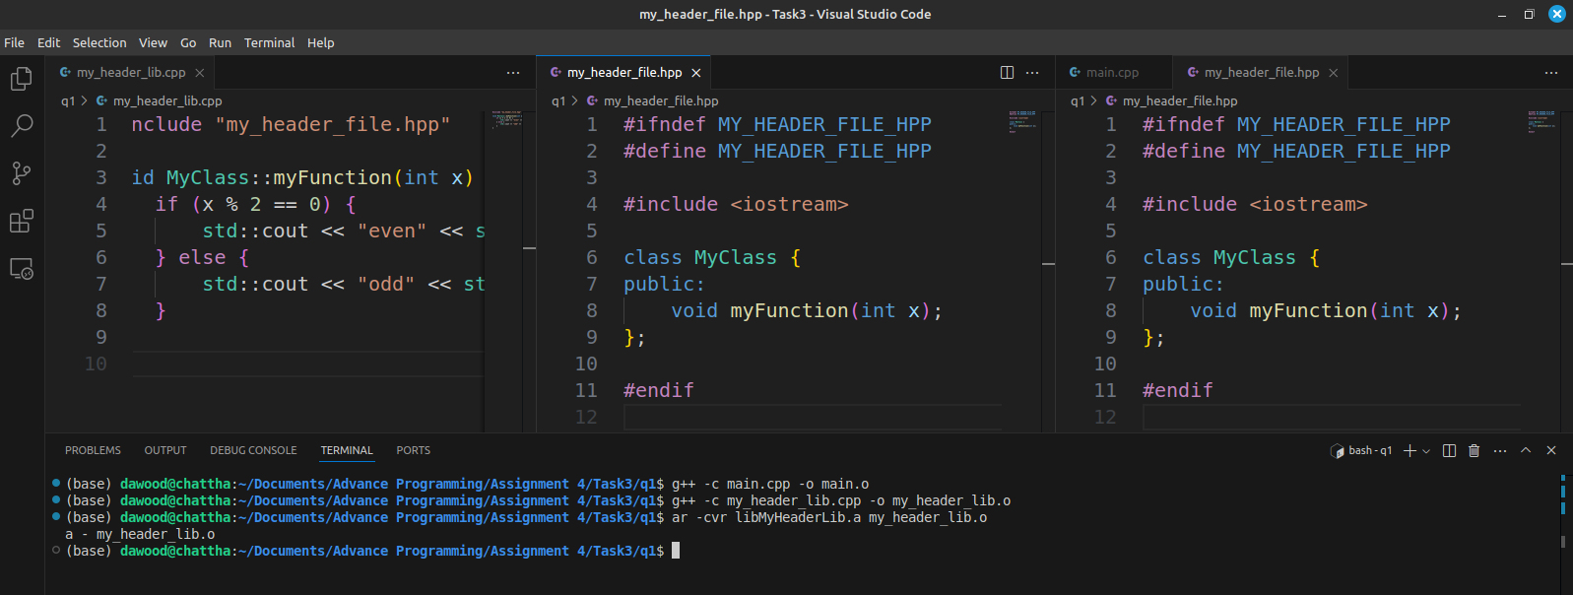

***Dynamic Library:***

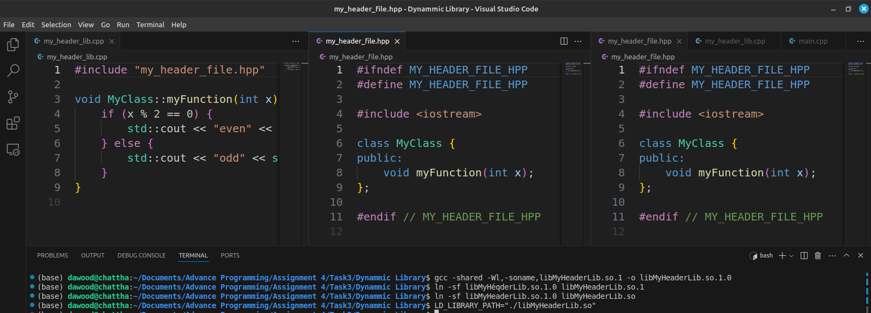

***1. What is the directory structure of your code before and after the***

***library creation.***

***Before library creation:***

├── main.cpp

├── my_header_file.hpp

└── my_header_lib.cpp

***After library creation:***

├── libMyHeaderLib.a

├── main.cpp

├── my_header_file.hpp

├── my_header_lib.cpp

└── my_header_lib.o

***After dynamic library creation:***

├── libMyHeaderLib.a

├── libMyHeaderLib.so

├── libMyHeaderLib.so.1

├── libMyHeaderLib.so.1.0

├── main.cpp

├── my_header_file.hpp

├── my_header_lib.cpp

└── my_header_lib.o

**2. *What are the CVR arguments?***

CVR Arguments:

● C: Create a new archive.

● V: Verbosely list files processed.

● R: Replace or insert files into the archive.

***3. Run the commands below and report their output:***

***1. readelf -S my_header_lib.o***

Lists the section headers of the object file.

***2. readelf -S your_final_file***

Lists the section headers of the final executable.